MS North West Therapy Centre Bulletin

November/December 2017: Issue 3 Volume 1


The Board of Directors wishes all our clients, staff, volunteers and benefactors a VERY HAPPY NEW YEAR.
We are very grateful to those who organised fund-raising events, gave donations, supported the Club Draw and gave of their time and efforts to enable us to provide services and supports to people with Multiple Sclerosis and other neurological conditions and their families.
In order that we keep our services to the highest standard we will be carrying out our Review of Services Questionnaire early in the New Year. This Review asks you to tell us what we are doing well and what we can improve on. When you receive it, please fill it in to the best of your ability and return to reception. If you have any queries or difficulty in filling it in, please ask Hilda or Nicola at reception for assistance.

Physiotherapy:
New MOTOmed Movement Therapy System at the MS Therapy Centre.
We at the MS North West Therapy Centre are delighted to say that we have been able to purchase a new Motomed (Viva) for use at the Centre. As you are aware the Centre is dependent on fundraising and donations to fully operate and new equipment is not cheap. We would therefore especially like to thank Breege Guihen (Joe Mooney Summer School), The Oxford Cycle and Glencar Lough Swim 2017 for all funds raised towards the purchasing of this fantastic piece of equipment.
All suitable clients will be eligible to use this MOTOmed at the Centre as part of ongoing Physiotherapy. We will also be able to increase our Community based MOTOmed service from 1 machine to 2, allowing clients to avail of one MOTOmed at home for a period of 2 months at a time.
Some Information on the MOTOmed System.
The MOTOmed Movement Therapy System is an Active / Passive exercise system for people with limited or no movement. The concept of MOTOmed Therapy is to get your muscles moving and keep them moving. This is done in one of 3 forms of training;
Passive Training – where the MOTOmed unit does all the work and your limbs passively follow the rotational movement in varying speeds,
Motor-Assisted Training – where you pedal using your own muscle strength but with assistance from the MOTOmed unit thus allowing you to maximise residual muscle strength, or
Active Training – where you pedal using your own muscle strength against varying levels of resistance.
If you are not currently using the MOTOmed or on our waiting list for accessing use at home but are interested in being assessed by our Physiotherapists to use it please contact us here at the Centre.
We would like to thank Breege Guihen (Joe Mooney Summer School), The Oxford Cycle and Glencar Lough Swim 2017 for all funds raised towards the purchasing of this MOTOMed Movement Therapy System.

MS 300 Club Draw:
Winners for November: | Winners for December:
1st Prize - €200 Geraldine Gordon | 1st Prize E200 Colm Deering (175)
2nd Prize - €50 Teresa Cahill | 2nd Prize E50 Dennis & Moira McGuinness (39)
3rd Prize - €25 Kitty Farren | 3rd Prize E25 Gerry & AnnMarie McPhelim (41)
4th Prize - €25 Moira McGuinness | 4th Prize E25 Cameron Roone (130)
 | 5th Prize Bottle Prosecco Christine McKenna (79)
6th, 7th, 8th, 9th, 10th Prize Bottle Wine
Sharon Foley (104),
Leon & Niall Murray (16),
Edith Bradley (43),
Stephen McGourty (98),
Ann & Gerry Flanagan (201)
Congratulations to all and many thanks for supporting the draw in 2017. All monies from the draw go towards providing essential supports and services to people with MS and other neurological conditions and their families. We ask that all our clients to take part in the draw which is an essential part of our fundraising efforts. For a small donation of €10 p/month you can be in with a chance to win prizes to the value of €300. Is your name in the drum? If not, please contact MS Reception for a Standing Order Form.
The draw is held on the last Friday of every month in the MS Centre.

Staff News:
Welcome to our new staff members: A big welcome to Hannah Gordon Physiotherapist, Hilda Fallon and Nicola McNally Reception, Dale Tonry and Zena Radulescu Care Assistants. Hope you enjoy your time with us!
Welcome back to our physiotherapist Aideen Melanaphy from her secondment at Sligo University Hospital.

Welcome to new baby! Congratulations to our physiotherapist Shane and his wife Avril on the arrival of their new baby girl, Layla Rose.

Fundraising Events:
The MS Centre relies on the generosity of our friends and neighbours in the community who organise events and give donations to the MS Centre. The Voluntary Fundraising Committee is looking for volunteers who would be able to assist with the fundraising events. This is a great way to make new friends and meet people while helping a good cause at the same time. If you or someone you know would like to give of their time and expertise to help with our fundraising, please contact Deirdre Murray at 087 9883196.
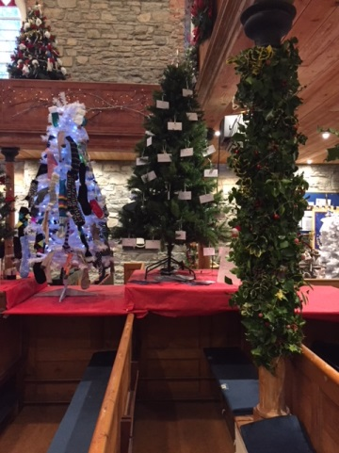
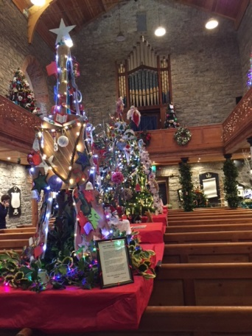
Christmas Tree Festival at Drumcliffe: The MS Therapy Centre took part in the Christmas Tree Festival at Drumcliffe Church in December. Our tree baubles feature clients’ comments about what the MS Centre means to them. Many thanks to Arlene for organising our tree. Thanks also to those who volunteered to sell our Christmas cards on site in the run-up to Christmas. Donations are accepted and are divided among all the charities present.

Castle Dargan Ladies Golf: Many thanks to Castle Dargan Ladies’ Golf for their generous donation of €200.
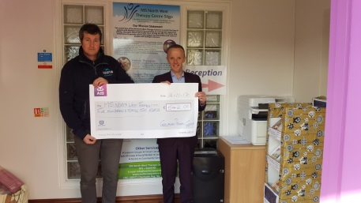
In spite of various setbacks, the Geevagh Annual Cycle team were undaunted and decided to hold their cycle on a stationary bike indoors raising €542 - thank you!
Bunninadden Table Tennis Club Tournament gave us a wonderful gift of €1,500.
The Annual Church Gate Collection (Sligo Town) yielded the amazing sum of €1372.82.
Raughley Swim: Congratulations to those who took part in the St. Stephen’s Day swim at Raughly. Proceeds in aid of MS NW Therapy Centre and SHOUT Cancer Care.

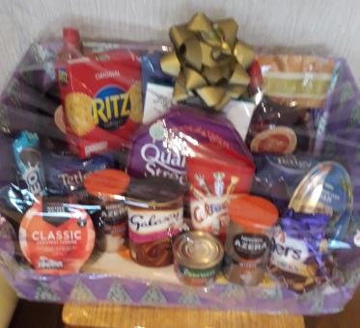
Many thanks to Stephen McGroarty who donated a beautiful hamper for our Christmas raffle for which we collected €240 and was won by Margaret and Charles McKemey.

We are very grateful to the organisers, the volunteers and the participants of these great fundraising activities for their generosity and donations to MS North West Therapy Centre - we are very grateful.

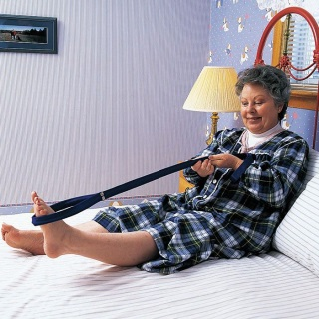
Gadget Search

Do you have a gadget that you find very useful and would like to share with our readers? If so, please let us know!

Here is my very useful gadget of the year – a handy leg lifter! It is very helpful when lifting my legs into the car.
It can be purchased at Homecare Pharmacy on the Pearse Road in Sligo (beside Roemer Furniture) at a very reasonable price.

If you have anything you would like me to include in the next Bulletin, please let us know at 086 3224402.
And so, as they say at the end of all good Walt Disney Cartoons,
THAT’S ALL FOLKS!

